# What fools AI?

Henry Liu (22672083)

Word conut: 7915



## Abstract

Deep learning has become a mainstay in computer vision, with applications ranging from self-driving cars to surveillance and security. At the same time, deep neural networks have shown surprising success in solving complex problems that are beyond human capabilities. Recent research has shown that they are susceptible to hostile attacks in the form of subtle perturbations to the input, leading to models that predict the wrong output. For images, such perturbations are usually too small to be detected, but they can completely fool deep learning models. Adversarial attacks pose a serious threat to the success of deep learning in practice. Despite their high accuracy, modern deep networks are vulnerable to adversarial attacks, which take the form of small perturbations to images that remain (almost) imperceptible to the human visual system. Such attacks can cause a neural network classifier to completely change its prediction of an image. Worse, the attacked model reports a high confidence in the wrong prediction. Moreover, the same image perturbation can deceive multiple network classifiers.

In this work, I investigate the following research question.

"When we feed adversarial input to deep learning, how the model attention changes compared to the clean inputs?"

To briefly summarize my research, we input a slightly perturbed version of data to change the output of the classifier to achieve a fooling effect that is almost imperceptible to the human eye, and explore the reasons for this intriguing behavior of deep learning by observing and analyzing the changes in the class activation maps (CAM) of the model under (adversarial) image manipulation.

This PROJECT will use popular self-supervised learning models such as SimCLR, SwAV, and fool them with existing methods and use CAMERAS technology to record and analyze the effect of the fooling. The core of the SimClR approach is that generic representations of images are learned from unlabeled datasets, and these generic representations of images can then be fine-tuned with a small number of labeled images to achieve a specific classification task with good performance. SwAV is a neural network that can be pre-trained without the use of annotations, which is simple and effective.

Table of contents

What fools AI? - 1 -

Abstract - 2 -

Introduction - 4 -

Literature Review - 6 -

1) Box-Constrained L-BFGS - 6 -

2) Fast Gradient Sign Method (FGSM) - 7 -

3) Basic & Least-Likely-Class Iterative Methods - 7 -

4) One Pixel Attack - 8 -

5) Universal Adversarial Perturbations - 8 -

6) Upset and ANGRI - 9 -

7) The Brendel & Bethge Attack - 9 -

1) SimCLR - 12 -

2) SwAV - 14 -

Experimental Design - 17 -

Result and Discussion - 24 -

The results of the experiments are presented and discussed in this section. - 24 -

1) Attack and visulization - 24 -

Conclusion - 35 -

Acknowledgements - 35 -

Reference - 36 -

## Introduction

Deep neural networks are susceptible to adversarial examples, inputs that are almost indistinguishable from natural data, but are misclassified by the network. There are also findings that suggest that the presence of adversarial attacks may be an inherent weakness of deep neural networks. The presence of attacks may be an inherent weakness of deep learning models.

The most important core of the rise of artificial intelligence is deep learning. Deep learning has become a mainstay in the field of computer vision for applications ranging from self-driving cars to surveillance and security. At the same time, deep neural networks have shown astonishing success in solving complex problems beyond the capabilities of humans. Recent research surfaces that they are vulnerable to hostile attacks in the form of subtle perturbations to the input, leading to models that predict the wrong output. For images, such perturbations are usually too small to be detected, yet they can completely fool deep learning models. Adversarial attacks pose a serious threat to the success of deep learning in practice.

Whereas deep learning performs a variety of computer vision tasks with remarkable accuracy, Szegedy et al [1] first identified an interesting weakness of deep neural networks for image classification. They showed that, despite their high accuracy, modern deep networks are surprisingly vulnerable to adversarial attacks in the form of small perturbations to images that remain (almost) imperceptible to the human visual system. Such attacks can cause a neural network classifier to completely change its prediction of an image. Even worse, the attacked model reports high confidence in the wrong prediction. Moreover, the same image perturbation can deceive multiple network classifiers. The far-reaching implications of these results have sparked widespread interest among researchers in adversarial attacks on deep learning in general and their defenses.

One such self-driving car, which had a stop sign ahead of it, was approaching but it didn't slow down; instead it accelerated into a busy intersection. Afterwards, an accident report showed that four small rectangles were affixed to the surface of the stop sign. These fooled the car's on-board artificial intelligence (AI) into misreading the word "stop" as "speed limit 45"[2]. While this is just one example and such an event has not yet actually happened, the potential for damaging AI is very real. Researchers have shown how to fool AI systems into misreading stop signs by carefully positioning stickers. They have fooled facial recognition systems by putting printed designs on glasses or hats. They have also fooled speech recognition systems into hearing hallucinatory phrases by inserting patterns of white noise into the audio.

Such adversarial attacks pose a serious threat to modern intelligent vision systems, from self-driving cars to personal devices.

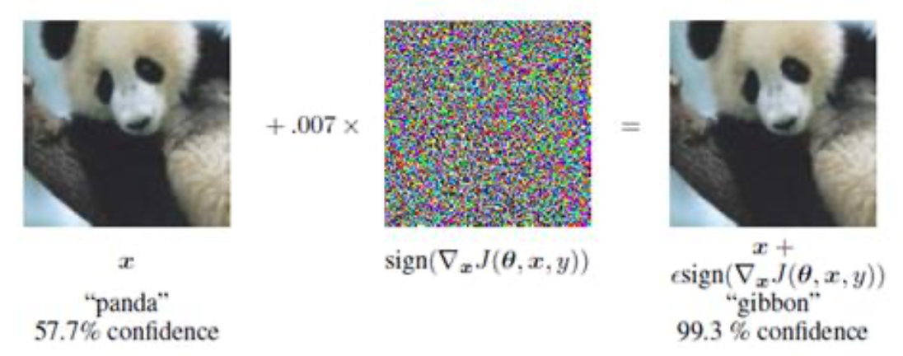

#### Figure 1: Sample x, whose label is panda, is still classified as panda in human eyes after adding partial interference to x, but for the depth model, it is misclassified as gibbon and gives a confidence level of up to 99.3%. [4]

This final project is using a CAM-like approach to see how fooling changes image saliency patterns, while this project focuses on self-supervised learning models, and the main experiment is simple. Eight adversarial attacks were performed on 2 self-supervised learning deep neural network models using 23 images. This resulted in the generation of 23 x 2 x 8 = 368 adversarial examples. The highest classification predictions (or labels) of the generated adversarial examples were recorded. In addition, the confidence levels of these predictions were recorded as well as the perturbations. This data can then be analyzed to gain insight into these attacks and/or models.

## Literature Review

This section provides an overview of many of the key attacks and models proposed in the field. In early 2018, Akhtar and Mian wrote a comprehensive survey on adversarial attacks on deep learning in computer vision. This survey covers many of the attacks, defenses, practical examples, and concepts published to date. It introduces the concept of adversarial examples and briefly discusses many ideas that have received widespread attention. Many of the attack algorithms and concepts in the survey have been investigated and are outlined in this literature review section.

2.1 Attacks

**The following are potential attacks from which a subset will be analysed.**

* Box-Constrained L-BFGS
* Fast Gradient Sign Method (FGSM)
* Basic & Least-Likely-Class Iterative Methods （BIM）
* One Pixel Attack
* Universal Adversarial Perturbations
* Upset and ANGRI

### 1) Box-Constrained L-BFGS

Szegedy et al [1] first demonstrated the possibility of small perturbations in images such that the perturbed images can fool deep learning models for misclassification. Let Ic ∈ Rm denote a vectorized clean image (the subscript 'c ' emphasizes that the image is clean and unscrambled data is added), Szegedy et al. propose to solve the following problem by computing an additive perturbation ρ ∈Rm that distorts the image very slightly to fool the network[1]:

$\min_{ρ} {||ρ||}_{2} s.t. C(I_{c} + ρ) = l; I_{c} + ρ ∈ {[0,1]}^{m},$ (1)

where $l$ denotes the label of the image and $C(.)$ is the deep neural network classifier, and the minimum value ρ of the following problem satisfies the condition $C(Ic+ρ)=l$ [8] :

$\min_{ρ} c|ρ| + L(I_{c}+ ρ, l) s.t. I_{c} + ρ ∈ {[0,1]}^{m},$ (2)

The above methods were able to compute perturbations that, when added to clean images, were able to fool neural networks, but for the human visual system, adversarial images are similar to clean images. szegedy et al. observed that perturbations computed for one neural network were also able to fool multiple networks [1]. These surprising results uncovered a blind spot in deep learning. At the time of this discovery, the computer vision community was rapidly adapting to the impression that perceptual distances are well approximated by Euclidean distances in the space defined by deep learning features. As a result, these contradictory results have sparked widespread interest among researchers in adversarial attacks on deep learning in computer vision.

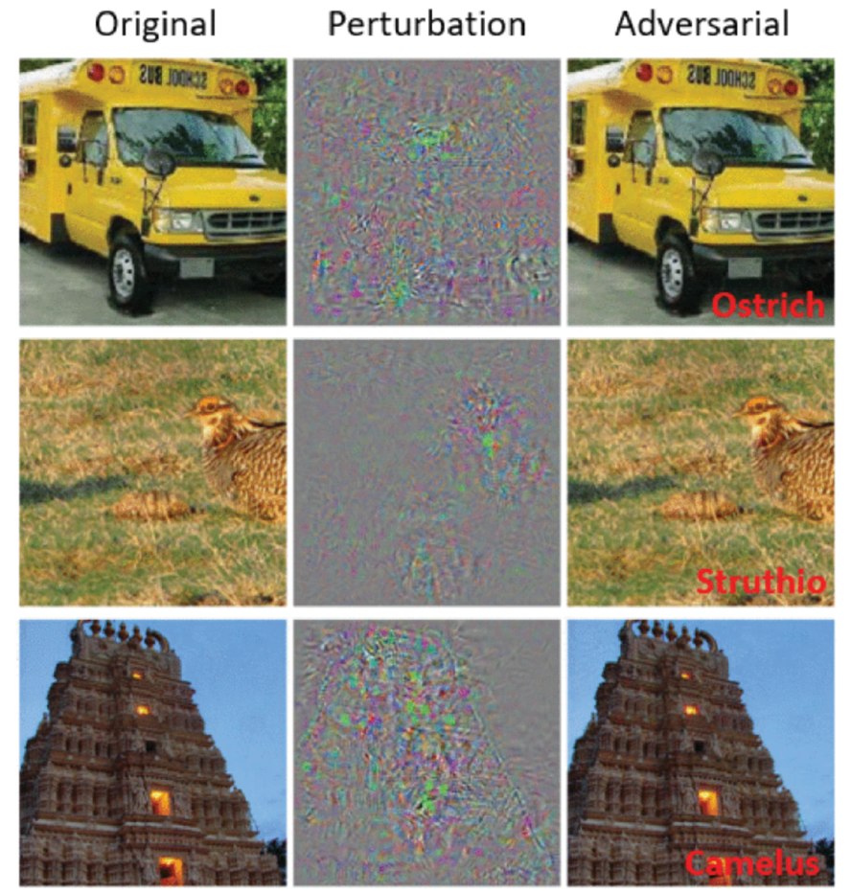

#### Figure 2: Illustration of adversarial examples generated using [1] for AlexNet [3]. The perturbations are magnified 10× for better visualization (values shifted by 128 and clamped). The predicted labels of adversarial examples are also shown[8].

### 2) Fast Gradient Sign Method (FGSM)

Szegedy et al [1] observed that the robustness of deep neural networks to adversarial instances can be improved by adversarial training. To achieve effective adversarial training to compute adversarial perturbations for a given image, Goodfellow et al [4] developed a method that solves the following problem by addressing:

$ρ = ∈ sign(∇J(θ,I_{c},l)),$ (3)

the model parameters $θ w.r.t. Ic , sign(.)$ denotes the sign function, and ϵ is a small scalar value that restricts the norm of the perturbation[8]. Linear behavior to obtain computational gains is encouraged in the design of modern deep neural networks, but this also makes them susceptible to cheap analytical perturbations.

### 3) Basic & Least-Likely-Class Iterative Methods

The Basic Iterative Method (BIM) [5] iteratively takes multiple small steps while reorienting after each step, taking multiple small steps in the direction of increasing classifier loss to perturb the image which is iteratively computed as follows:

$I_{ρ}^{i+1} = {Clip}_{∈}\{I_{ρ}^{i}+αsign(∇J(θ,I_{ρ}^{i},l)\},$ (4)

where $I_{ρ}^{i}$ denotes the perturbed image at the i-th iteration, $Clip ϵ\{.\}$ Clip (pixel-valued) image at its parameter $ϵ,$ and $α$ determines the step size (usually, $α$ =1 ). the BIM algorithm starts from $I_{ρ}^{0}=I_{c}$ and runs for the number of iterations determined by the equation $⌊min(ϵ+4,1.25ϵ)⌋$ [8].

Madry et al [6] state that BIM is equivalent to the ( $l∞$ version of) projected gradient descent method, which is a standard convex optimization method.

### 4) One Pixel Attack

Is it possible to fool the classifier by changing only one pixel in the image? It is certainly possible, and this is an extreme case of adversarial attacks, as Su et al [7] claim to have successfully fooled three different network models by changing only one pixel in each image on 70.97% of the tested images. They also reported that the network was found to have an average confidence level of 97.47% for mislabeling. Naveed et al [8] show a representative example of the adversarial images in [7] in Figure 3.

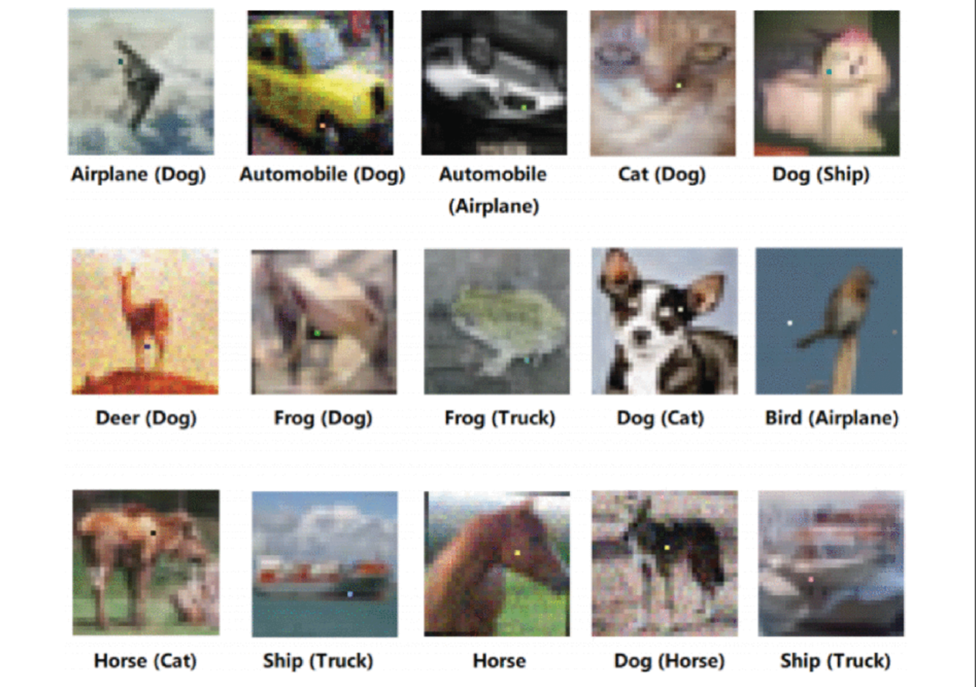

#### Figure 3: The adversarial attack for one pixel with the corresponding correct label for each image and the corresponding predicted label in parentheses[7]

### 5) Universal Adversarial Perturbations

In contrast to fooling the classifier on a single image, the "generic" adversarial perturbation computed by Moosavi-Dezfooli et al [9] is able to fool the network with high probability on "any" image. A perturbation ρ is "universal" if it satisfies the following constraint.

$P_{I_{c}\sim J_{c}}(C(I_{c}≠C(I_{c}+ρ))≥δ s.t. {||ρ||}_{p}≤ξ,$ (6)

where $P(.)$ denotes the probability, δ ∈ (0,1] is the fooling rate, ||. ||p denotes the $l$ p-norm, and $ξ$ is a predefined constant. the smaller the value of $ξ$, the harder it is to perceive perturbations in the image[8].

The algorithm proposed by Moosavi-Dezfooli et al [9] computes perturbations while targeting a single network model, such as ResNet [10]. However, it turns out that these perturbations also generalize well to different networks (especially those with similar architectures). In this sense, the author claims that these perturbations are somehow "doubly general". Furthermore, it is shown that high fooling rates (e.g., $δ$ ≥ 0.5 ) can be achieved by learning a perturbation using only about 2, 000 training images.

### 6) Upset and ANGRI

Sarkar et al [11] proposed two black-box attack algorithms, namely UPSET. universal Perturbations for Steering to Exact Targets, and ANGRI: Antagonistic Network for Generating Rogue Images, for directionally fooling deep neural networks. For class 'n', UPSET tries to generate 'n' image-independent perturbations so that when a perturbation is added to an image that does not belong to the target class, the classifier will classify the perturbed image as an image of that class. the power of UPSET comes from a residual generation network R(.) , which takes the target class 't' as input and generates a perturbation R(t) for fooling. The overall approach uses the so-called UPSET network to solve the following optimization problems.

$I_{ρ}=max\left(min\left(sR\left(t\right)+I_{c},1\right),-1\right),$ (7)

where the pixel values in $I_{c}$ are normalized to lie in [-1, 1] and ' $s$' is a scalar. To ensure that Iρ is a valid image, all values outside the interval $[-1, 1]$ are clipped[8].

In contrast to the image-independent perturbations of UPSET, ANGRI computes image-specific perturbations in a closely related manner, for which we refer to the original work.The perturbations generated by ANGRI can also be used for directed fooling. Both algorithms have been reported to achieve high fooling rates on the MNIST [12] and CIFAR-10 [13] datasets.

### 7) The Brendel & Bethge Attack

Developed by Brendel et al. (2019), it is a combination of a boundary attack and a gradient attack [14]. The attack works by starting with an adversarial sample point that is far from a clean input. It then estimates the local geometry of the boundary between the adversarial and non-adversarial regions and walks along the adversarial boundary towards the clean input. It tries to minimize the distance to the clean input while staying on the adversarial boundary. It can be found that this attack outperforms previous attacks in almost all cases, and tests are performed in L-0, l-1, l2, and l-inf metrics, targeted and untargeted, on six different models, with full hyperparameter tuning for the other attacks.

2.2 Self-supervised learning methods

In addition to developing more powerful attacks, developing defenses and more robust models is also a major research point. Developing more powerful attacks is often associated with developing more powerful models. Adversarial examples generated by stronger attacks can be used to train classification models and improve their resistance to similar attacks, which is called adversarial training.

In this project I used a self-supervised learning model. Self-supervised learning is a special purpose unsupervised learning. Unlike traditional methods such as AutoEncoder, which aim at reconstructing the input only, it hopes to learn features associated with high-level semantic information through surrogate task. First of all, let us introduce what exactly is SSL (self-supervised learning), we know that generally machine learning is divided into supervised learning, unsupervised learning and reinforcement learning. Self-supervised learning is a kind of unsupervised learning, which mainly hopes to learn a generic feature representation for downstream tasks.

Self-supervised learning can be considered as an "ideal state" of machine learning, where the model learns directly from unlabeled data, without labeling the data. The core of self-supervised learning is how to automatically generate labels for the data. For example, input an image, rotate the image by a random angle, and then use the rotated image as input and the randomly rotated angle as the label. Another example is to divide the input image into a 3*3 grid evenly, and the content inside each grid as a patch, randomly disrupt the order of the patches, and then use the disordered patches as input, and the correct order as label. similarly, this kind of automatically generated labeling does not require human involvement at all.

How to evaluate the performance of self-supervised learning? The performance of self-supervised learning is evaluated by the quality of the features learned by the model, which are used in other vision tasks (classification, segmentation, object detection, ...) by means of transfer learning. The quality of a feature is evaluated by the quality of the result of the vision task. There is no unified and standard way of evaluation.

A research set for self-supervised learning. As mentioned earlier, the core of self-supervised learning is how to automatically generate labels for the input data. Much of the previous work has been centered on this core. The general routine is: first propose a new auxiliary task for automatic labeling (pretext task, e.g., rotate images, disrupt patch order), use the auxiliary task to automatically generate labels, and then do experiments, measure performance, and publish articles. New auxiliary tasks are proposed every year, and the performance of self-supervised learning is improving, and some of them have even approached the performance of supervised learning. In general, either a completely new auxiliary task is proposed, or several old auxiliary tasks are combined together as a "new" auxiliary task.

In general, finding the right auxiliary task (pretext) is the most important problem to be solved for self-supervised learning. The more data and resources are available, the better the results of self-supervised pretraining will be.

The main way is by supervising itself, for example, by removing a few words from a paragraph and using its context to predict the missing words, or by removing some parts of a picture and relying on the information around it to predict the missing patch.

And self-supervised learning is divided into two main categories.

1. Generative Methods; 2. Contrastive Methods.

For the first class Generative Methods, these methods focus on the reconstruction error of pixel space, mostly on the loss of pixel label. They are mainly represented by AutoEncoder, and the later deformations, such as VAE, etc. The basic requirement for the encoder is to preserve the important information of the original data as much as possible, so if the original image can be decoded by decoder, it means that the latent code reconstruction is good enough.

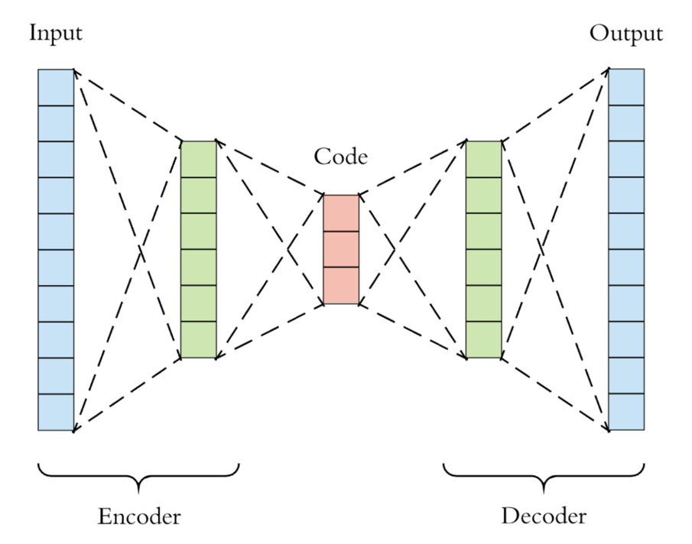

#### Figure 4: The basic model of Generative Methods[15].

For a RMB, we can easily distinguish its authenticity, which means that we have extracted a good feature representation, which is sufficient to portray the RMB information. But if you ask me to draw a picture of the exact same RMB, I will not be able to do so. It is clear from this example that a sufficient condition for extracting a good representation is the ability to reconstruct, but it is not a necessary condition, so there is a first class of Generative Methods.

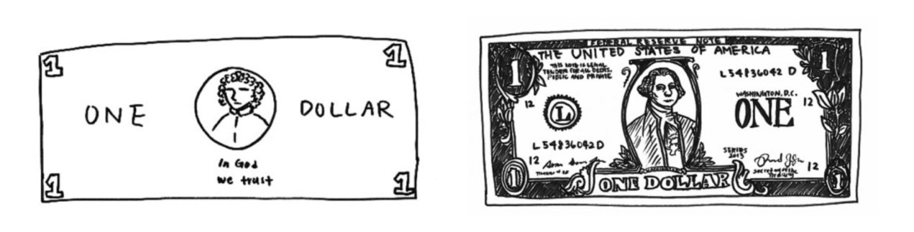

#### Figure 5: Left: A dollar bill drawn from memory. Right picture. Subsequent drawings made with a dollar bill in hand. [16]

In addition to such Generative methods as above, there is another class of methods that are based on contrastive methods. These methods do not require the model to be able to reconstruct the original input, but to be able to discriminate between different inputs in the feature space, as in the example of USD above.

These methods have the following characteristics.

1. constructing a distance metric on feature space.

2. allowing multiple prediction results through feature invariance.

3. using Siamese Network.

4. no pixel-level reconstruction is required.

The following is a summary image of these two types of methods.

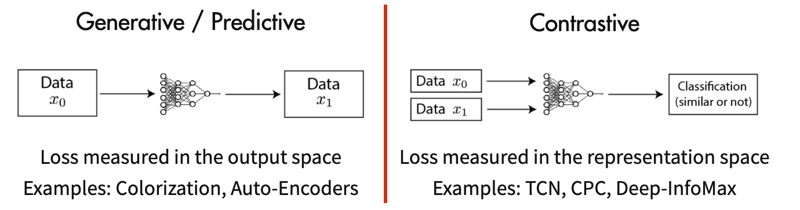

#### Figure 6：Comparison of Generative vs Contrastive Methods

Because these methods do not require pixel-level reconstruction, optimization becomes easier. Of course, these methods are not without drawbacks, because there is no label in the data, so the main problem is how to take and construct positive and negative samples.

At present, the contrastive-based methods have achieved good tension, and are close to the effect of supervised learning on classification, while even surpassing supervised learning as a pre-train method on some downstream tasks of detection and segmentation.

### SimCLR

The rationale for using SimCLR in this project is simple: it builds a simple framework for contrast learning for visual representation, SimCLR, which not only outperforms all previous work and the latest contrast self-supervised learning algorithms, but also has a simpler structure: neither a specialized architecture nor a special repository is required. SimCLR is a simple and clear approach that does not require class labeling SimCLR is a simple and clear way for AI to learn visual representations without the need for class labeling, and it can achieve supervised learning accuracy. According to the authors, SimCLR achieves a Top-5 accuracy of 85.8% after fine-tuning 1% of the image labels on ImageNet - outperforming AlexNet with only 1% of its labels.

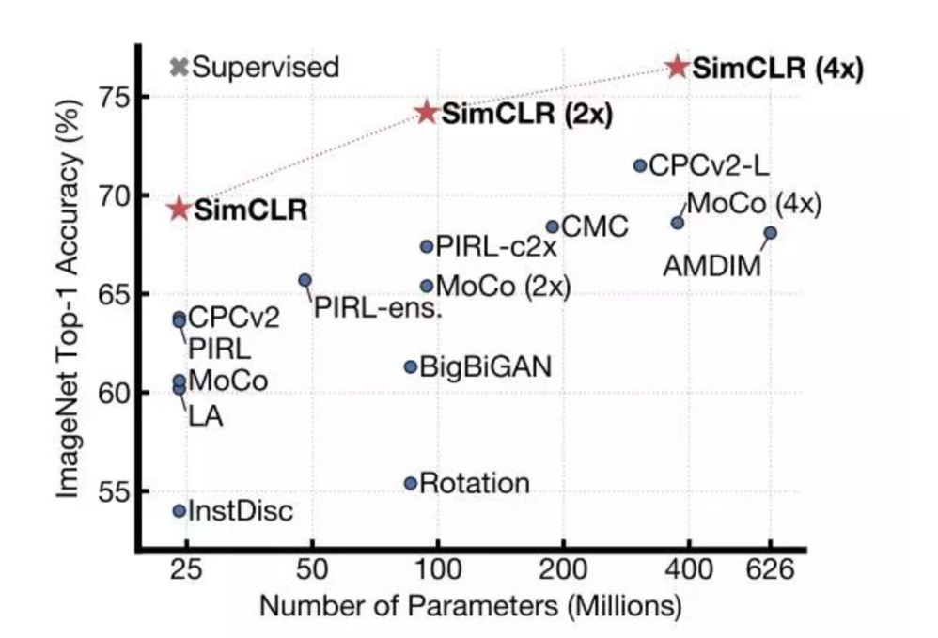

#### Figure 7: Top-1 accuracy of SimCLR vs. previous types of self-supervised methods on ImageNet (pre-trained with ImageNet), and the supervised learning effect of ResNet-50 (gray x)[16].

Researchers found that:

1. A combination of multiple data augmentation methods is important to produce effective representations for comparison prediction tasks. Furthermore, data augmentation is more useful for unsupervised learning compared to supervised learning.

2. Introducing a learnable nonlinear transformation between the representation and the contrast loss can substantially improve the quality of the representation learned by the model.

3. Contrast learning benefits from larger batch sizes and more training steps than supervised learning.Based on these findings, they implemented a new semi-supervised, self-supervised learning SOTA method, SimCLR, on the ImageNet ILSVRC-2012 dataset. This is a 7% improvement over the previous SOTA. With fine-tuning using only 1% of ImageNet tags, SimCLR achieves a top-5 accuracy of 85.8%, a 10% improvement over the previous SOTA method. When fine-tuned on 12 other natural image classification datasets, SimCLR showed comparable or better performance than the strongly supervised learning baseline on 10 datasets.

The idea concept of SimCLR is actually quite simple: (1) first SAMPLING some images (batch); (2) doing two different DATA augmentations on the IMAGES in the batch; (3) expecting similar results for the same image, different augmentations, and mutually exclusive other results.

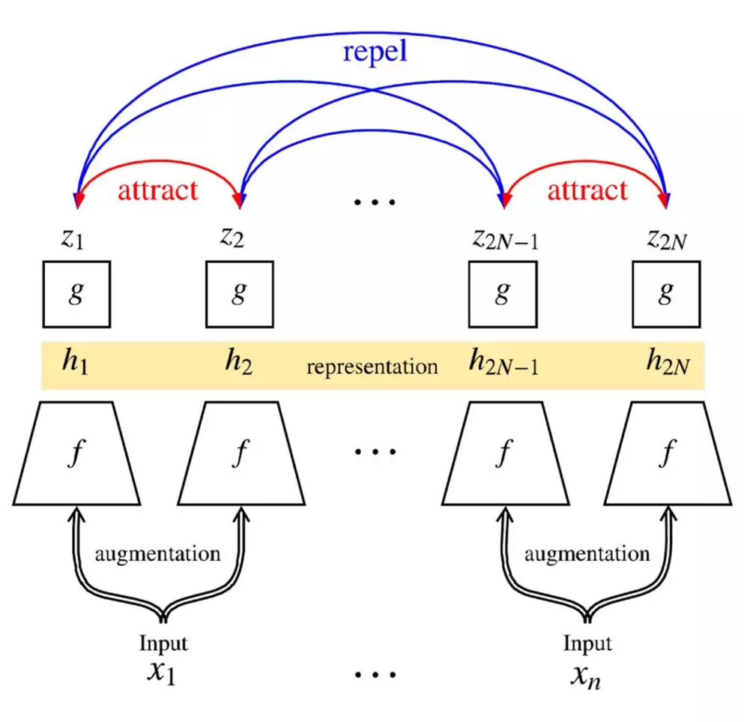

#### Figure 8: SimCLR implementation flowchart[16].

SimCLR versus previous methods in terms of linear estimation. In addition, the table also shows more numerical comparisons between the different methods. As can be seen from the table, the SimCLR method using the ResNet-50 (4×) architecture is able to obtain results comparable to those of supervised pre-trained ResNet-50.

### SwAV

The distance between unsupervised image representations and supervised ones has been narrowed in recent years, among which there is a good progress in conventional learning. Therefore, the paper focuses on proposing an online algorithm, swAV, which can draw on the ideas of contrastive learning but can avoid a lot of computation:

1. proposes a scalable online clustering loss that can improve at least 2% over existing self-supervision methods on the imagenet, and can be trained on large and small batch sizes without requiring large memory overhead or momentum encoder

2. Introducing the multi-crop strategy can increase the number of views of an image without increasing the memory and computational overhead, and using this technique can consistently improve the effect of multiple self-supervised methods by 2%-4% on the imagenet.

3. Putting the above related improvements on the resnet model can improve more than 4.2% on imagenet compared to the self-supervised method, and the pretrain model can perform better on multiple downstream tasks compared to the supervised algorithm on imagenet.

Overall, the article proposes an online clustering-based self-supervised approach. The traditional clustering-based approach generally does clusters (codes) on the entire dataset based on image features, and does clusters on many image views in a training step. The traditional clustering-based approach is generally based on the image feature in the entire dataset to make a cluster (codes), in a training step will be a lot of image views to do cluster, but this method usually need to sweep the dataset many times is not suitable for online scenarios. The method in this paper does not consider using codes as the target, but by the need to maintain consistent codes of different views of an image to learn, so this method can be understood as a number of different views of an image need to correspond to the same cluster rather than directly using their features to do.

As shown in the figure below, we can see the similarities and differences between this method SwAV and the contrastive instance learning method, mainly in the feature comparison piece, SwAV uses a code to express the features and then to maintain consistency, we can see that the training mainly consists of two parts

1）How z(features) is reflected by c(prototypes) and Q(codes) is obtained by shooting

2）How Q completes the loss calculation by Swapped Prediction

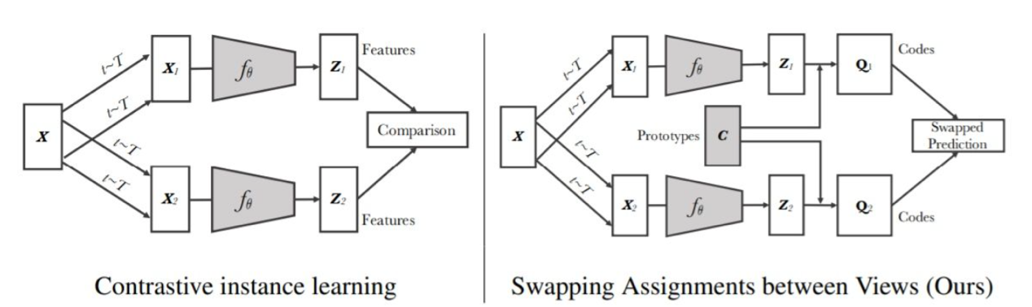

#### Figure 9: Overview of SwAV method[17]

Evaluate the performance of unsupervised learned features in imagenet in the experiment

By fixing the learned features and using a linear classifier to learn them, the effect is 4.2% higher than the existing unsupervised one and only 1.2% lower than the supervised one, as shown in the left figure below

Before SwAV, there were also deep unsupervised learning methods based on clustering such as Deep Cluster [18], but Deep Cluster requires computing cluster assignment for the whole dataset as the label for model training, which has a large computational overhead. SwAV calculates the code online and then keeps the code consistent under different views of the same batch of images.

In addition to introducing clustering, SwAV also proposes a "multi-crop" image transformation method, which further improves the results. In [19], it is shown that more views can improve the effectiveness of the self-supervised learning model. multi-crop increases the number of views with smaller-sized images without increasing the extra memory and computational requirements. Direct manipulation of reduced-size images may introduce bias to the features, but this bias can be avoided by blending of different sizes.

Personally, I feel that it is natural for SwAV to have powerful effects with additional prior information from clustering and a data enhancement strategy like Multi-crop.

2.4 Visulisation

This section introduces the visualization technique Grad-CAM

As we all know, deep learning is a "black box" system. It works in an "end-to-end" way, with input data such as RGB images and output targets such as category labels, regression values, etc. The process in between is not known. How can we open the "black box" and find out what is going on, so that the "black box" can become a "gray box" or even a "white box"? How can we open the "black box" and find out what is going on, so that the "black box" becomes a "gray box" or even a "white box"? Therefore, there is the field of "deep learning interpretability", and CAM (Class Activation Mapping) technology is one of them, which uses feature visualization to explore the working mechanism and judgment basis of deep convolutional neural networks.

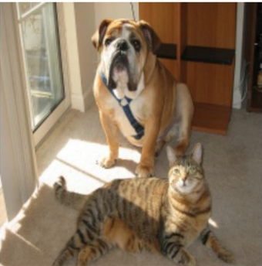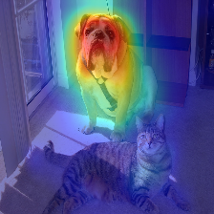

#### Figure 11: Original image + CAM heat map overlay[20]

CAM has the following functions:

It helps to understand and analyze the working of neural networks and the decision making process, so as to better select or design the network. For example, for classification networks, if we refer to CAM, it is equivalent to a higher requirement for the network in addition to the classification accuracy: not only does it require a high prediction accuracy, but it also requires the network to extract the features we need. As can be seen in the figure below, the CAM of different networks for the same data is more significantly different. Of course, even for the same network, different training processes can lead to significant differences in CAM.

Using visual information to guide the network for better learning, e.g. CAM information can be used to enhance the data by "erasing" or ""cropping"".

Using CAM as the original seed for weakly supervised semantic segmentation or weakly supervised localization. Since CAM is able to cover to the target object, it can be used to complete the semantic segmentation or target detection task using only classification annotation, which greatly reduces the annotation workload, but it is more demanding for CAM. In general, the classification network will only extract to the most discriminative features. So there are also many practices to improve the CAM accuracy of classification networks, as follows.

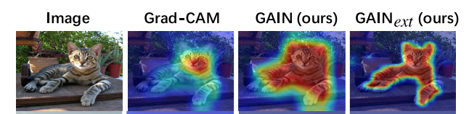

#### Figure 12: Improve CAM accuracy[21]

The difference between grad-CAM and CAM is that

1. CAM can only be used for operations where the last layer between the feature map and the output is GAP, while grad-CAM can be applied to non-GAP connected network structures.

2. CAM can only extract the heat map of the last layer of the feature map, while grad-CAM can extract any layer.

Grad-CAM is better than CAM and easier to implement, so grad-CAM is chosen for this project.

## Experimental Design

This section outlines the experiments and components of these experiments.

3.1. main experiments

## 1）Experimental setup

First compute the adversarial samples by attacking the self-supervised model (illustration), then compute the attention maps for clean and disturbed images using the image saliency method (illustration), and analyze these results.

The main experiments are simple. 8 adversarial attacks were run with 23 images against 2 self-supervised learning deep neural network models. This resulted in generating 23 x 2 x 8 = 368 adversarial examples. The highest classification predictions (or labels) of the generated adversarial examples were recorded. In addition, the confidence levels of these predictions are recorded as well as the perturbations. This data can then be analyzed to gain insight into these attacks and/or models.

## 2) Data sets

Data sets: Give details and examples of the data used.

The 23 images used in this project are listed below, and these 23 images will be attacked by the 8 attack algorithms mentioned above.

Clean image:

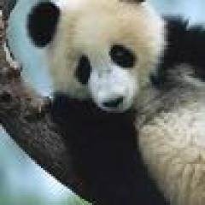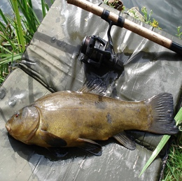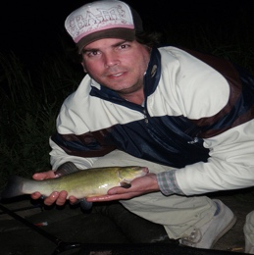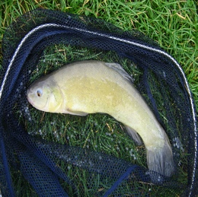

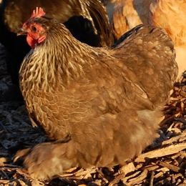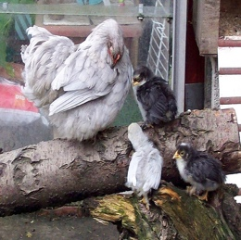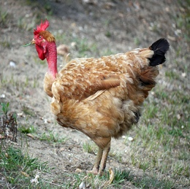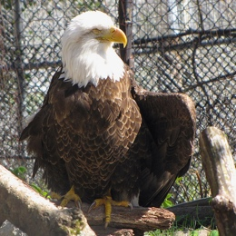

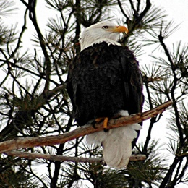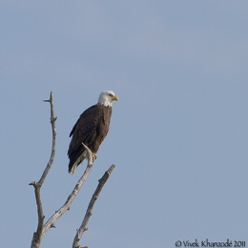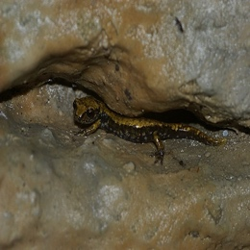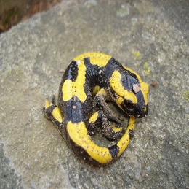

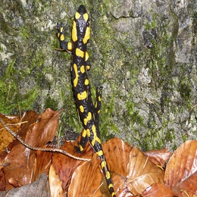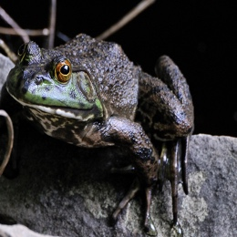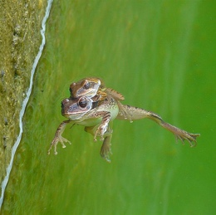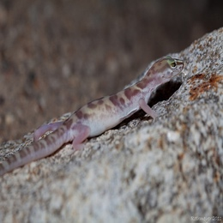

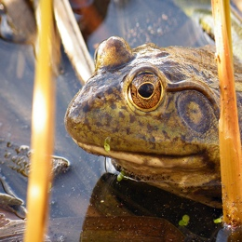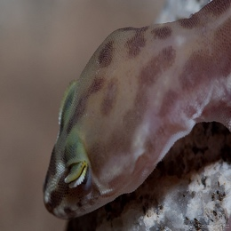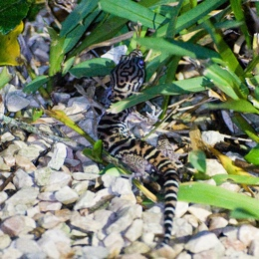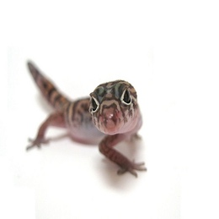

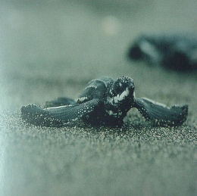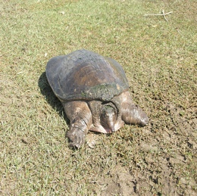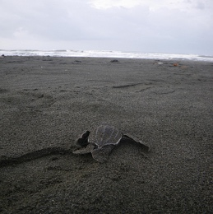

#### Figure 13: 23 clean images from imageNet

Due to space limitations in this final report, 5 images are listed below along with their post-attack images and images identified using Cameras，more experimental results can be found

(https://github.com/Henryboy233/research-project-GENG5512/tree/main).

## 3) Attack parameter setting

After applying different kinds of attack algorithms to clean images, Grad-CAM's observation of the distribution of images, this project successfully implemented 8 algorithmic attacks, which are (listed below)：

* Basic & Least-Likely-Class Iterative Methods （BIM）
* CW ( Towards Evaluating the Robustness of Neural Networks )
* DIFGSM ( Input diversity + FGSM )
* FFGSM
* Fast Gradient Sign Method (FGSM)
* RFGSM ( Random initialization + FGSM )
* Square
* VANILA

All results have been uploaded to the github repository.

(https://github.com/Henryboy233/research-project-GENG5512/tree/main)

|  |  |  |  |  |  |  |
| --- | --- | --- | --- | --- | --- | --- |
| Attacks Method | eps | Alpha/lr/  n_queries | Steps/  n_restarts | parameter | parameter | Total running  time |
| BIM | eps=8/255, | alpha=2/255, | steps=100) |  |  | #55.11 |
| CW | c=1, | lr=0.01, | steps=100, | kappa=0) |  | #6.01 |
| DIFGSM | eps=8/255 | alpha=2/255 | steps=100, | diversity_prob=0.5 | resize_rate=0.9 | #49.62 |
| FFGSM | eps=8/255 | alpha=10/255) |  |  |  | #1.01 |
| FGSM | eps=8/255 |  |  |  |  | #1.04 |
| RFGSM | eps=8/255 | alpha=2/255, | steps=100) |  |  | #49.03 |
| Square | eps=8/255 | n_queries=5000 | n_restarts=1 | loss='ce' |  | #4.38 |
| VANILA |  |  |  |  |  | #0.52 |

#### Table 1：The eight attack methods used in this use and the parameters used

This final project determines whether the attack is successful by looking at the label. To facilitate understanding, we choose the first image (giant panda as an example) and first print out its True Image & True Label.

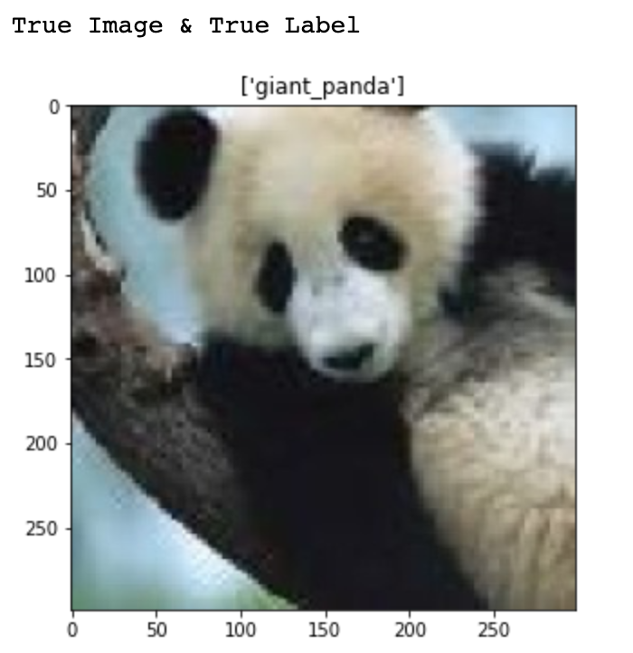

#### Figure 14: True Image & True Label of Giant Panda (clean image).

The attack method was started to be applied to clean images, and the results were as follows (only one clean image was selected to show the results due to the space limitation of the report):

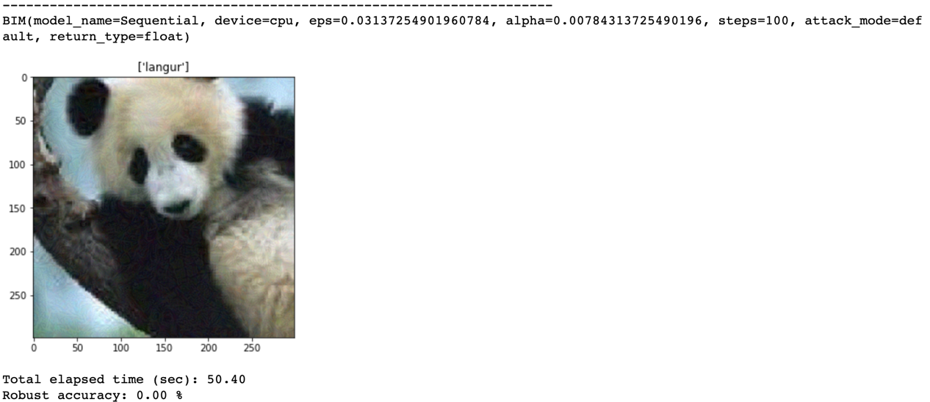

#### Figure 15: The result after applying the attack method（BIM）

This is the result after applying the BIM attack method, the parameters applied have been listed in table 1 above, the label has changed, from giant_panda to langur, which can be judged as a successful attack!

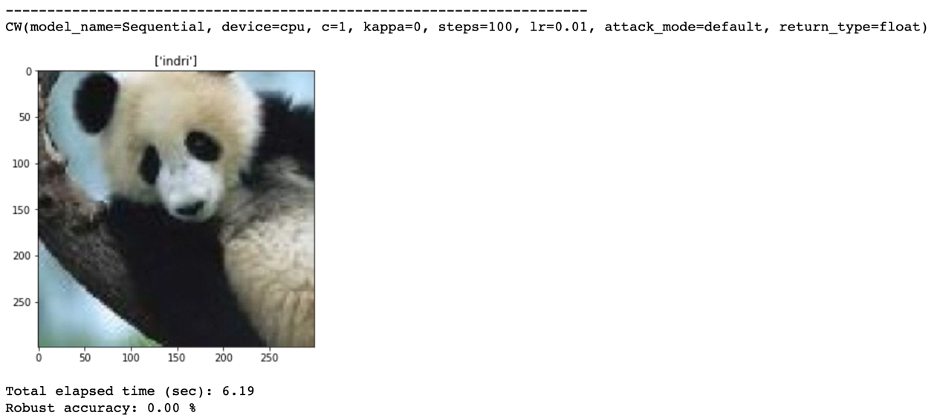

#### Figure 16: The result after applying the attack method（CW）

This is the result after applying the CW attack method, the parameters applied have been listed in table 1 above, the label has changed, from giant_panda to indri, which can be judged as a successful attack!

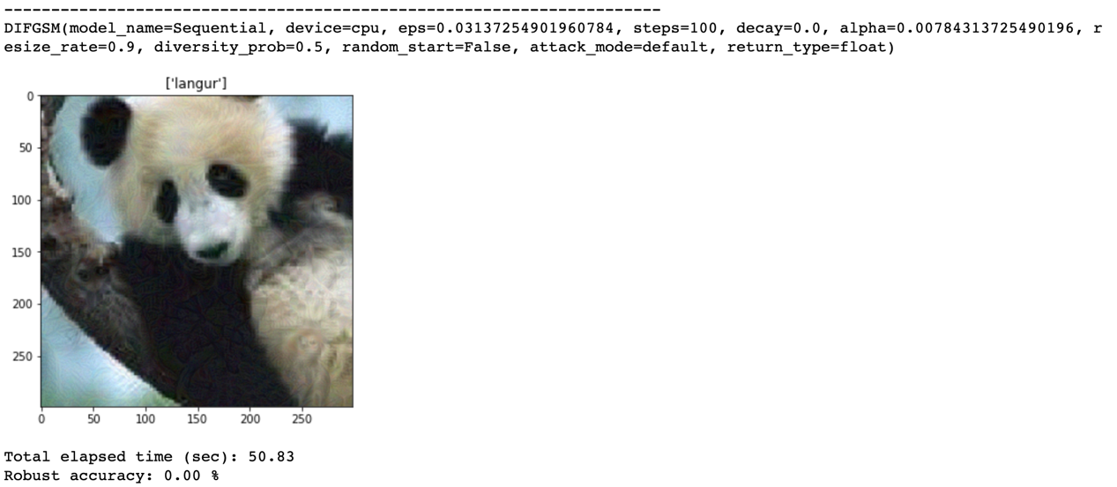

#### Figure 17: The result after applying the attack method（DIFGSM）

This is the result after applying the DIFGSM attack method, the parameters applied have been listed in table 1 above, the label has changed, from giant_panda to langur, which can be judged as a successful attack!

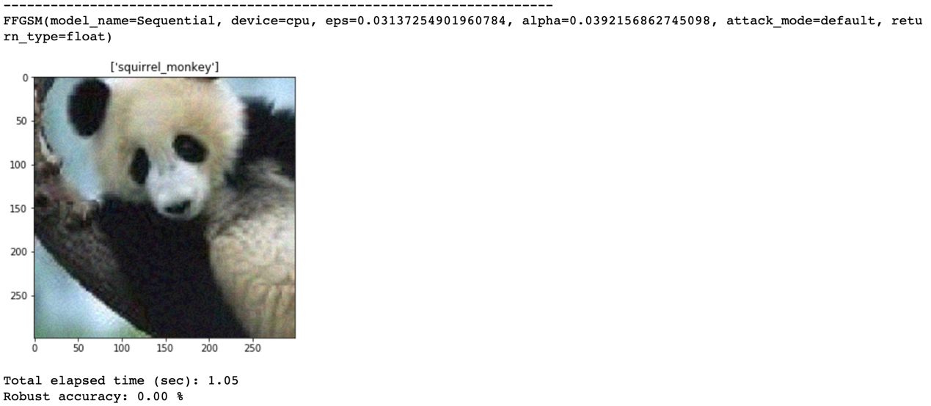

#### Figure 18: The result after applying the attack method（FFGSM）

This is the result after applying the FFGSM attack method, the parameters applied have been listed in table 1 above, the label has changed from giant_panda to squirrel_monkey, which can be judged as a successful attack!

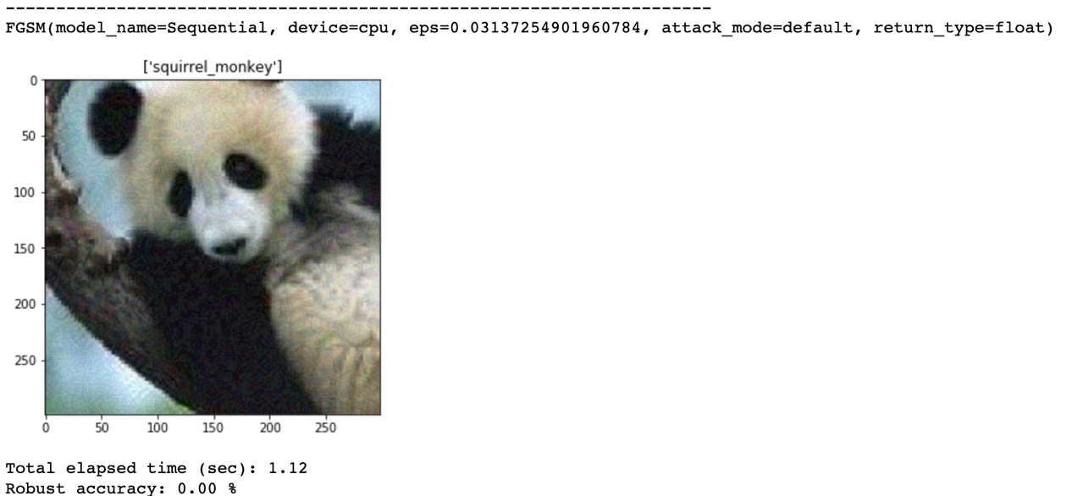

#### Figure 19: The result after applying the attack method（FGSM）

This is the result after applying the FGSM attack method, the parameters applied have been listed in table 1 above, the label has changed from giant_panda to squirrel_monkey, which can be judged as a successful attack!

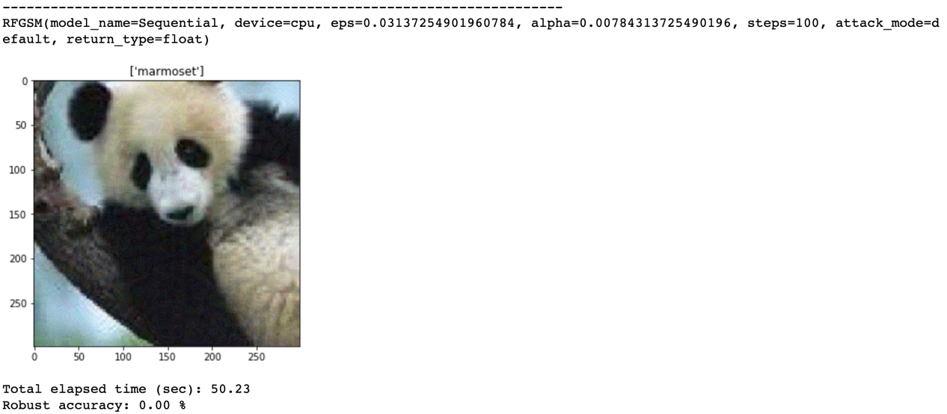

#### Figure 20: The result after applying the attack method（RFGSM）

This is the result after the RFGSM attack method is applied, the parameters applied have been listed in table 1 above, the label has changed from giant_panda to marmoset, which can be judged as a successful attack!

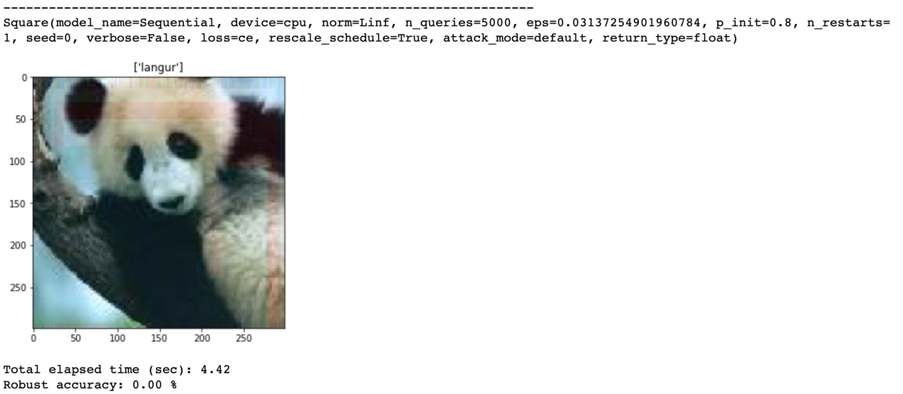

#### Figure 21: The result after applying the attack method（Square）

This is the result after applying the Square attack method, the parameters applied have been listed in table 1 above, the label has changed, from giant_panda to langur, which can be judged as a successful attack!

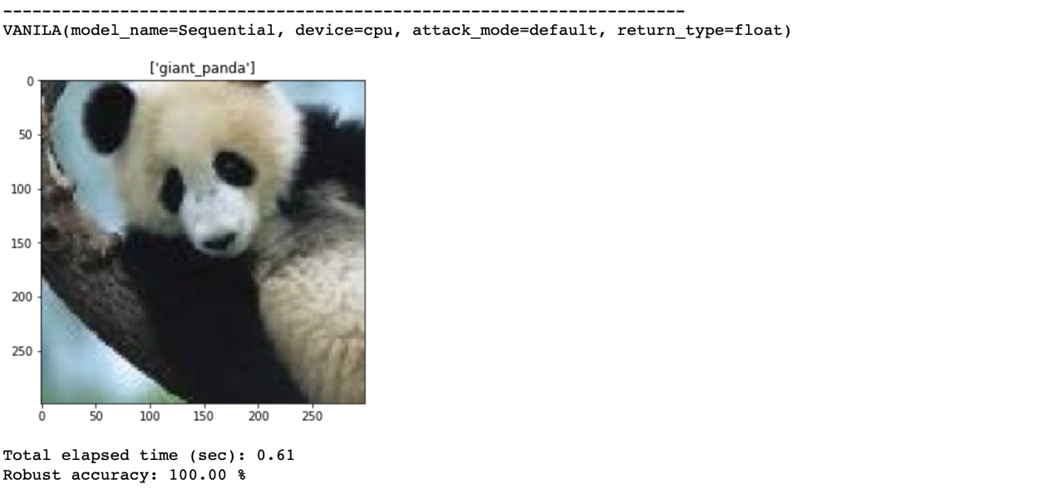

#### Figure 22: The result after applying the attack method（VANILA）

This is the result after applying the VANILA attack method, the parameters applied have been listed in table 1 above, the label has not changed, the label is still giant_panda after the giant_panda attack, it can be judged as a failed attack, but the result of this attack method will be retained for comparison with other attack methods.

The above shows the results of eight kinds of attacks applied to a picture, in order to ensure the reliability of the experiment, this experimental project will be applied to 23 pictures and record the results, the above process can be regarded as a successful attack on a picture.

## Result and Discussion

The results of the experiments are presented and discussed in this section.

### Attack and visulization

All images will be placed in the order of the attacks: clean image (figure left 1), attack with BIM (figure middle 1), attack with CW (figure right 1), attack with DIFGSM (figure left 2), attack with FFGSM (figure middle 2), attack with FGSM (figure right 2), attack with RFGSM (figure left 3), attack with Suqare (figure middle 3), attack with VANILA (figure right 3)，all based on SimCLR.

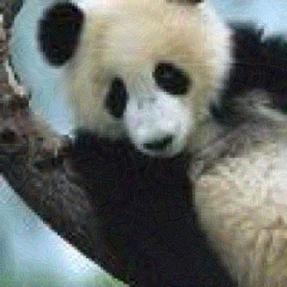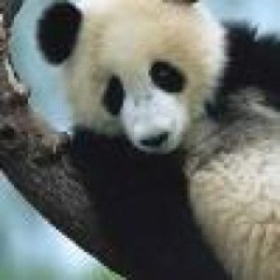

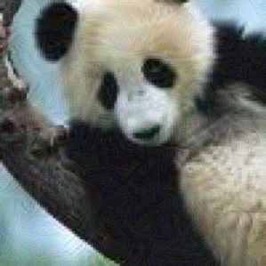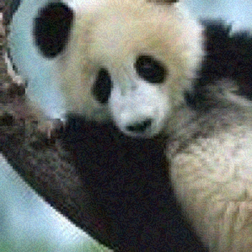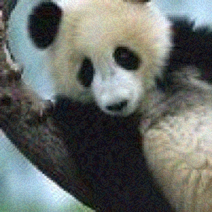

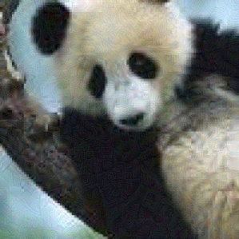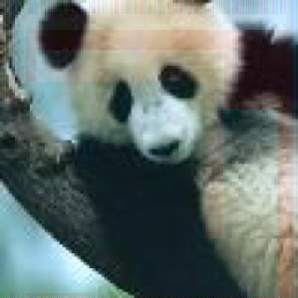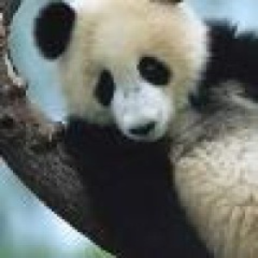

#### Figure 14: Labeled as pictures of pandas. All images will be placed in the order of the attacks, which are: clean image (figure left 1), attack using BIM (figure middle 1), attack using CW (figure right 1), attack using DIFGSM (figure left 2), attack using FFGSM (figure middle 2), attack using FGSM (figure right 2), attack using RFGSM (figure left 3), attack using Suqare attack (Figure middle 3), attack using VANILA (Figure right 3)

For such a clean image (panda), after applying the attack algorithm, the human eye does not very intuitively see the difference between different images, except for some special images, such as in Figure 14 (Figure 3) which more obviously have red boxes on the right and upper side, the rest of the images cannot see significant differences.

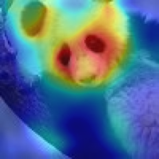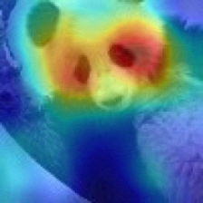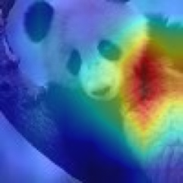

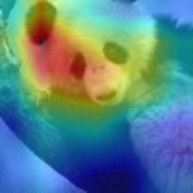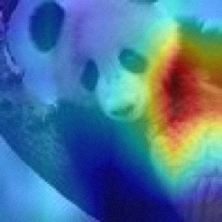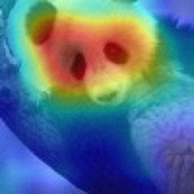

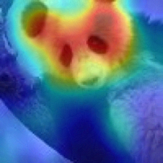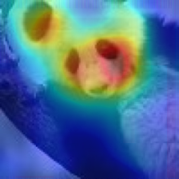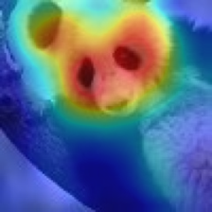

#### Figure 15: The images labeled as pandas are the results after using Cameras recognition. All images are placed in the order of the attacks: clean image (Figure left 1), attack using BIM (Figure middle 1), attack using CW (Figure right 1), attack using DIFGSM (Figure 2 on the left), attack using FFGSM (Figure middle 2), attack using FGSM (Figure right 2), attack using RFGSM (Figure left 3), attack using Suqare attack (Figure middle 3), attack using VANILA (Figure right 3)

For such a clean image (panda), after applying the attack algorithm, although the difference between the different images is not very intuitive to the human eye, the focus of the SimCLR model has changed significantly, more obviously in Figure 15 (Figure 1 on the right) and (Figure 2 in the middle), the red area represents the focus area of the machine (in other words the AI), which has shifted from the panda's face to the right side, and the focus areas of the other images after the attack have also changed to a greater or lesser extent.

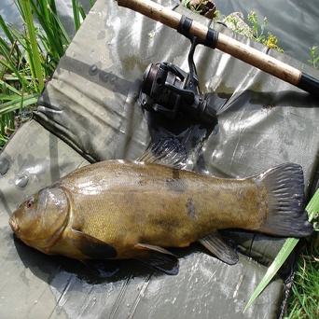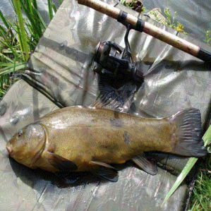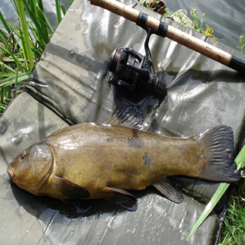

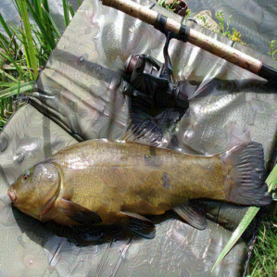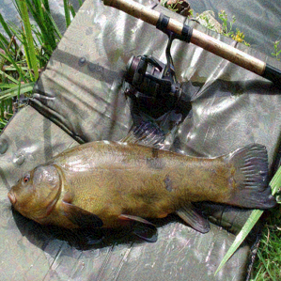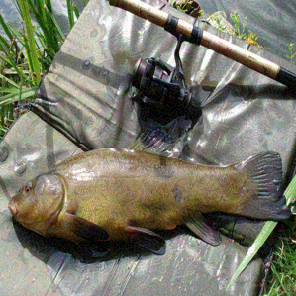

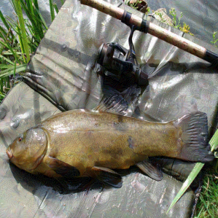

#### Figure 16: Labeled as pictures of fish. All images are placed in the order of the attacks: clean image (figure left 1), attack using BIM (figure middle 1), attack using CW (figure right 1), attack using DIFGSM (figure left 2), attack using FFGSM (figure middle 2), attack using FGSM (figure right 2), attack using RFGSM (figure left 3), attack using Suqare attack (Figure middle 3), attack using VANILA (Figure right 3)

For such a clean picture (fish), the difference between the different pictures is not very intuitive to the human eye after applying the attack algorithm.

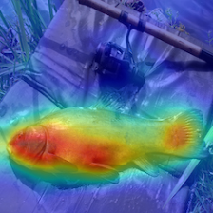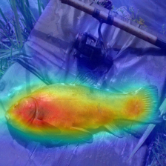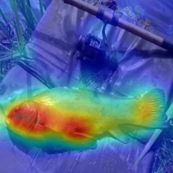

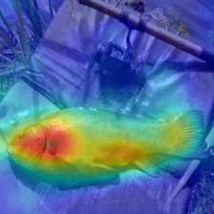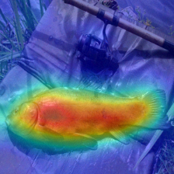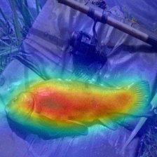

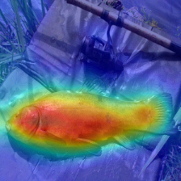

#### Figure 17: The pictures labeled as fish are the results after using Cameras recognition. All images are placed in the order of the attacks: clean image (Figure left 1), attack using BIM (Figure middle 1), attack using CW (Figure right 1), attack using DIFGSM (Figure left 2), attack using FFGSM (Figure middle 2), attack using FGSM (Figure right 2), attack using RFGSM (Figure left 3), attack using Suqare attack (Figure middle 3), attack using VANILA (Figure right 3)

For such a clean image (fish), after applying the attack algorithm, although the difference between the different images is not very intuitive to the human eye, the focus of the SimCLR model has changed significantly, more obviously in Figure 17 (Figure right 2), (Figure middle 2) and (Figure left 3), the red area represents the focus area of the machine (in other words the AI), which has been biased from the face of the fish to the whole body of the fish, and the focus area of the other images after the attack has also changed to a greater or lesser extent.

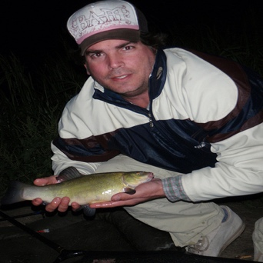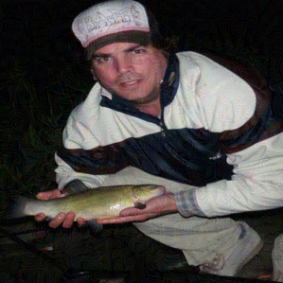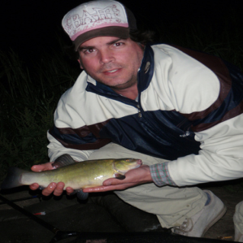

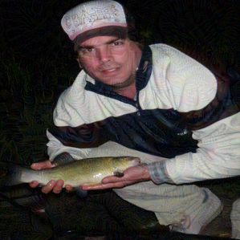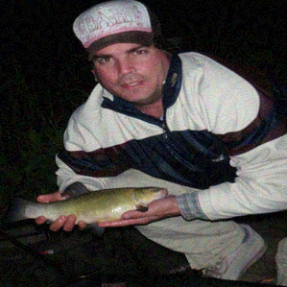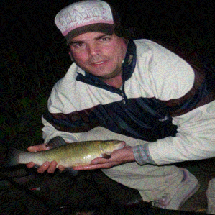

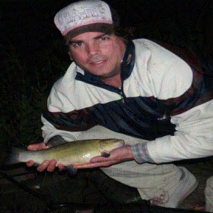

#### Figure 18: Tagged as chef and fish pictures. All images are placed in the order of the attacks: clean image (figure left 1), attack using BIM (figure middle 1), attack using CW (figure right 1), attack using DIFGSM (figure left 2), attack using FFGSM (figure middle 2), attack using FGSM (figure right 2), attack using RFGSM (figure left 3), attack using Suqare attack (Figure middle 3), attack using VANILA (Figure right 3)

For such a clean picture (chef and fish), the human eye does not see the difference between the different pictures very intuitively after applying the attack algorithm.

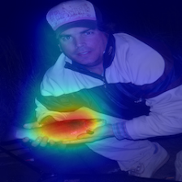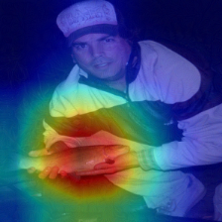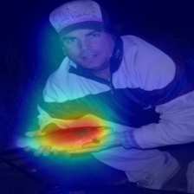

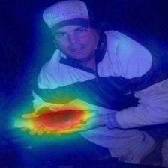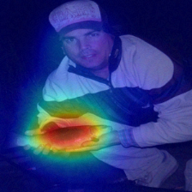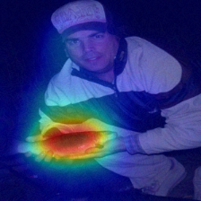

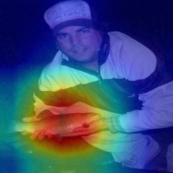

#### Figure 19: The labels are the results of the chef and fish images after using Cameras recognition. All images are placed in the order of the attacks: clean image (Figure left 1), attack using BIM (Figure middle 1), attack using CW (Figure right 1), attack using DIFGSM (Figure left 2), attack using FFGSM (Figure middle 2), attack using FGSM (Figure right 2), attack using RFGSM (Figure left 3), attack using Suqare attack (Figure middle 3), attack using VANILA (Figure right 3)

For such a clean image (chef and fish), the focus of the SimCLR model also does not change significantly after the attack algorithm is applied, only in Figure 15 (Figure 1 middle) and (Figure left 3) the red area is expanded, the other images do not change much after the attack

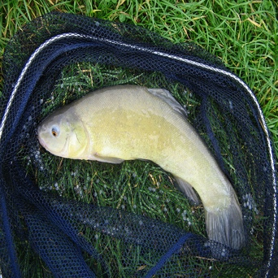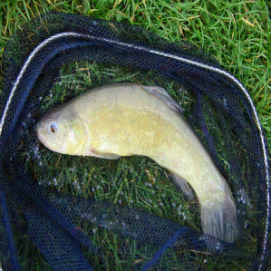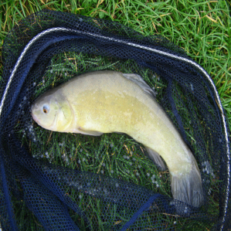

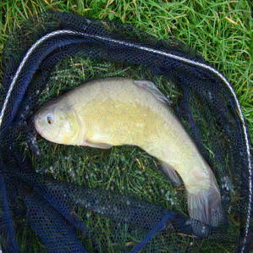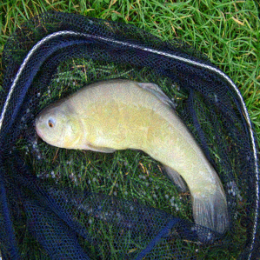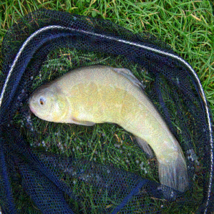

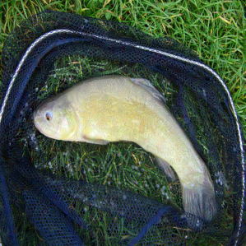

#### Figure 20: Labeled as pictures of fish. All images are placed in the order of the attacks: clean image (figure left 1), attack using BIM (figure middle 1), attack using CW (figure right 1), attack using DIFGSM (figure left 2), attack using FFGSM (figure middle 2), attack using FGSM (figure right 2), attack using RFGSM (figure left 3), attack using Suqare attack (Figure middle 3), attack using VANILA (Figure right 3)

For such a clean picture (fish), the difference between the different pictures is not very intuitive to the human eye after applying the attack algorithm.

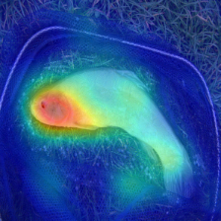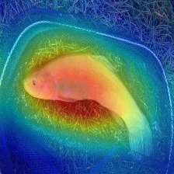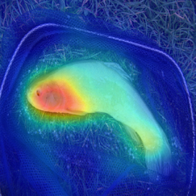

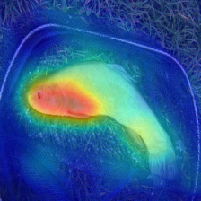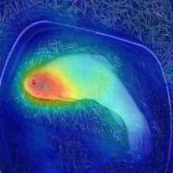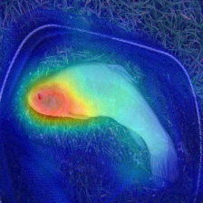

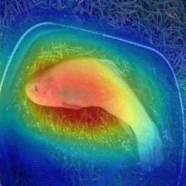

#### Figure 21: The pictures labeled as fish are the results after using Cameras recognition. All images are placed in the order of the attacks: clean image (Figure 1 on the left), attack using BIM (Figure 1 on the middle), attack using CW (Figure 1 on the right), attack using DIFGSM (Figure 2 on the left), attack using FFGSM (Figure 2 on the middle), attack using FGSM (Figure 2 on the right), attack using RFGSM (Figure 3 on the left), attack using Suqare attack (Figure middle 3), attack using VANILA (Figure right 3)

For such a clean picture (fish), the focus of the SimCLR model also does not change significantly after the attack algorithm is applied, only in Figure 15 (Figure 1) and (Figure left 3) the red area is expanded, the other pictures do not change much after the attack.

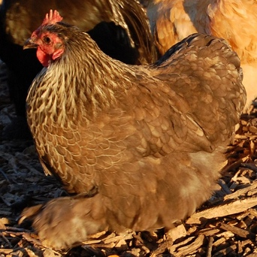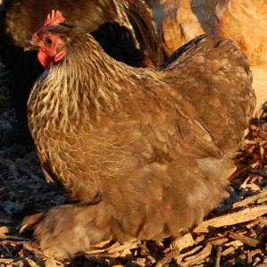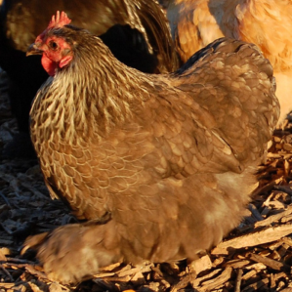

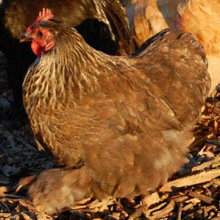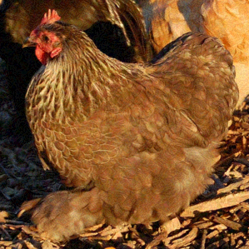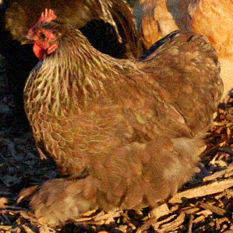

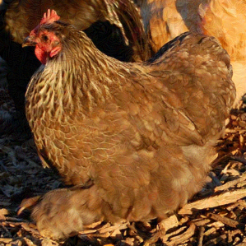

#### Figure 22: The pictures labeled as Rooster. All images are placed in the order of the attacks: clean image (figure left 1), attack using BIM (figure middle 1), attack using CW (figure right 1), attack using DIFGSM (figure left 2), attack using FFGSM (figure middle 2), attack using FGSM (figure right 2), attack using RFGSM (figure left 3), attack using Suqare attack (Figure middle 3), attack using VANILA (Figure right 3)

For such a clean image (rooster), the difference between the images is not very intuitive to the human eye after applying the attack algorithm.

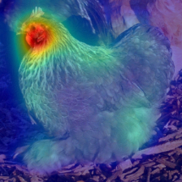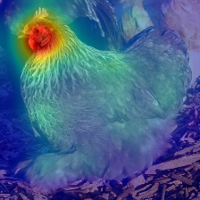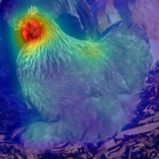

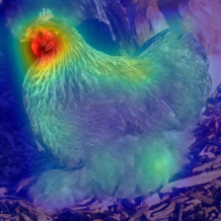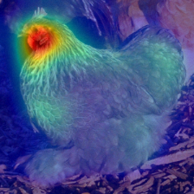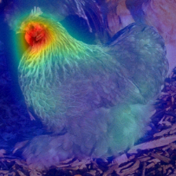

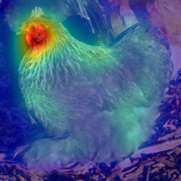

#### Figure 23: The images labeled as roosters are recognized using Cameras after the results. All images are placed in the order of the attacks: clean image (Figure 1 on the left), attack using BIM (Figure 1 on the middle), attack using CW (Figure 1 on the right), attack using DIFGSM (Figure 2 on the left), attack using FFGSM (Figure 2 on the middle), attack using FGSM (Figure 2 on the right), attack using RFGSM (Figure 3 on the left), attack using Suqare attack (Figure middle 3), attack using VANILA (Figure right 3)

For such a clean picture (attack), the focus of the SimCLR model does not change significantly even after imposing the attack algorithm, which seems to indicate that SimCLR successfully defends against the attack（Succeed！）.

## Conclusion

In this research project, I performed 23 sets of experiments, imposing eight attack algorithms on each clean image, which were then fed into two self-supervised learning models. The aim was to find commonalities and differences between the adversarial attacks and the models. The main experiments yielded 348 adversarial examples for analysis. A neural network model had a greater impact on predicting the adversarial examples than the adversarial attacks themselves. Different attacks applied to the same image produced different results. Similar attacks against models with lightweight architectures tend to result in the same adversarial labels. These findings can be explained by considering the potential classification space of the models. These insights may help future researchers to develop more robust models to counter these untargeted, gradient-based attacks. Since these attacks are gradient-based, some future work will be to consider other attacks. Further research is still needed regarding the differences in the impact of the same attack algorithm on the same model in different images.

## Acknowledgements

In a flash, a whole year of final year project has come to an end. In retrospect, these days have been long and short, full of sweet and sour, but also full of harvest and growth.

From choosing the topic of my thesis, collecting data to writing the thesis, I have received many teachers and students' enthusiastic help. First of all, I would like to thank my supervisor, Dr. Naveed Akhtar, who gave me a lot of valuable advice on my research and gave me a goal and direction in writing my thesis, and whose rigorous attitude and knowledge, unpretentious and easy-going personality had a profound impact on me and is a role model for me to follow throughout my life!

Secondly, I would like to thank all the teachers who have taught me, their kind teaching has given me endless enlightenment, thank you very much! I am also grateful for the hard work of my predecessors in the field of deep learning, which has brought great convenience to those who come after me. I would like to dedicate my best wishes to you, and may you always be healthy and happy!

I would also like to thank UWA for giving me the resources and support for my higher education. UWA will always be my backing, and I will always remember that I come from UWA wherever I go, and I want to make UWA proud. I also thank all the administrative teachers who have helped me.

Finally, I would like to thank my parents and friends who have been by my side during this year for all their helpful suggestions and advice, for their help in finding information to complete my dissertation, for their support and assistance in my life, and for their efforts to make my family's life happier and better in the future!

## Reference

1. C. Szegedy et al., Intriguing properties of neural networks, 2014, [online] Available: <https://arxiv.org/abs/1312.6199>.
2. Eykholt, K. et al. IEEE/CVF Conf. Comp. Vision Pattern Recog. **2018**, 1625–1634 (2018).

**3.** A. Krizhevsky, I. Sutskever and G. E. Hinton, "ImageNet classification with deep convolutional neural networks", Proc. Adv. Neural Inf. Process. Syst., pp. 1097-1105, 2012.

**4.** I. J. Goodfellow, J. Shlens and C. Szegedy, Explaining and harnessing adversarial examples, 2015, [online] Available: <https://arxiv.org/abs/1412.6572>.

**5.** A. Kurakin, I. Goodfellow and S. Bengio, Adversarial examples in the physical world, 2016, [online] Available: <https://arxiv.org/abs/1607.02533>.

**6.** A. Madry, A. Makelov, L. Schmidt, D. Tsipras and A. Vladu, Towards deep learning models resistant to adversarial attacks, 2017, [online] Available: <https://arxiv.org/abs/1706.06083>.

**7.** J. Su, D. V. Vargas and S. Kouichi, One pixel attack for fooling deep neural networks, 2017, [online] Available: <https://arxiv.org/abs/1710.08864>.

**8.** Akhtar N , Mian A . Threat of Adversarial Attacks on Deep Learning in Computer Vision: A Survey[J]. IEEE Access, 2018.

**9.** S. M. Moosavi-Dezfooli, A. Fawzi, O. Fawzi and P. Frossard, "Universal adversarial perturbations", Proc. IEEE Conf. Comput. Vis. Pattern Recognit. (CVPR), pp. 86-94, Jul. 2017.

**10.** K. He, X. Zhang, S. Ren and J. Sun, "Deep residual learning for image recognition", Proc. IEEE Conf. Comput. Vis. Pattern Recognit., pp. 770-778, Jun. 2016.

**11.** S. Sarkar, A. Bansal, U. Mahbub and R. Chellappa, UPSET and ANGRI: Breaking high performance image classifiers, 2017, [online] Available: <https://arxiv.org/abs/1707.01159>.

**12.** Y. LeCun et al., "Backpropagation applied to handwritten zip code recognition", Neural Comput., vol. 1, no. 4, pp. 541-551, 1989.

**13.** A. Krizhevsky, "Learning multiple layers of features from tiny images", 2009.

**14.** W. Brendel, J. Rauber, M. Kümmerer, I. Ustyuzhaninov and M. Bethge, “Accurate, reliable and fast robustness evaluation,” 12 Dec 2019. [Online]. Available: https://arxiv.org/abs/1907.01003.

**15.** Image source. Available: <https://aeon.co/essays/your-brain-does-not-process-information-and-it-is-not-a-computer>

**16.** Chen, T., Kornblith, S., Norouzi, M., and Hinton, G. A simple framework for contrastive learning of visual representations. arXiv preprint arXiv:2002.05709, 2020.

**17.** Caron et al., Unsupervised Learning of Visual Features by Contrasting Cluster Assignments. 2020. Available: https://arxiv.org/pdf/2006.09882.pdf

**18.** Caron, M., Bojanowski, P., Joulin, A., & Douze, M. (2018). Deep clustering for unsupervised learning of visual features. In Proceedings of the European Conference on Computer Vision (ECCV) (pp. 132-149). <http://openaccess.thecvf.com/content_ECCV_2018/papers/Mathilde_Caron_Deep_Clustering_for_ECCV_2018_paper.pdf>

**19.** Misra, I., & Maaten, L. V. D. (2020). Self-supervised learning of pretext-invariant representations. In Proceedings of the IEEE/CVF Conference on Computer Vision and Pattern Recognition (pp. 6707-6717). <http://openaccess.thecvf.com/content_CVPR_2020/papers/Misra_Self-Supervised_Learning_of_Pretext-Invariant_Representations_CVPR_2020_paper.pdf>

**20.** Selvaraju, R.R., Cogswell, M., Das, A. *et al.* Grad-CAM: Visual Explanations from Deep Networks via Gradient-Based Localization. *Int J Comput Vis* **128,**336–359 (2020). https://doi.org/10.1007/s11263-019-01228-7

**21.** K. Li et al., Tell Me Where to Look: Guided Attention Inference Network. Available: <https://arxiv.org/pdf/1802.10171.pdf>